**Practical – 3**

**Aim: -** Design SQL language within MySQL and PHP to access and manipulate databases.

**Code: -**

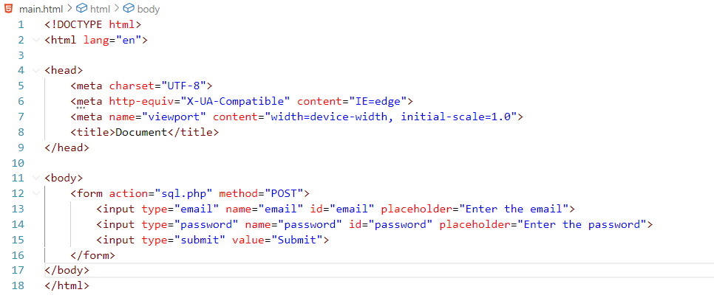

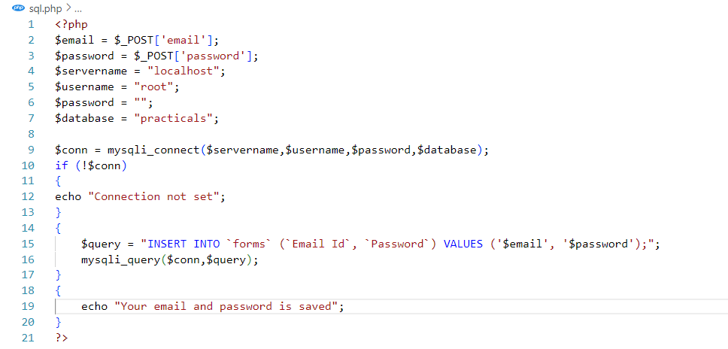

**Result: -**

